
3G TS 34.124 V3.2.0 (2001-01)
Technical Specification
3rd Generation Partnership Project;
Technical Specification Group Terminals;
Electromagnetic compatibility (EMC) requirements
for Mobile terminals and ancillary equipment
(Release 1999)

The present document has been developed within the 3rd Generation Partnership Project (3GPP TM) and may be further elaborated for the purposes of 3GPP.
The present document has not been subject to any approval process by the 3GPP Organisational Partners and shall not be implemented.
This Specification is provided for future development work within 3GPP only. The Organisational Partners accept no liability for any use of this Specification.
Specifications and reports for implementation of the 3GPP TM system should be obtained via the 3GPP Organisational Partners' Publications Offices.

Keywords
UMTS, EMC
3GPP
Postal address

3GPP support office address
650 Route des Lucioles - Sophia Antipolis
Valbonne - FRANCE
Tel.: +33 4 92 94 42 00 Fax: +33 4 93 65 47 16
Internet
http://www.3gpp.org
Copyright Notification
No part may be reproduced except as authorized by written permission.
The copyright and the foregoing restriction extend to reproduction in all media.

© 2000, 3GPP Organizational Partners (ARIB, CWTS, ETSI, T1, TTA,TTC).
All rights reserved.
Contents
Foreword 5
1 Scope 6
2 References 6
3 Definitions and abbreviations 8
3.1 Definitions 8
3.2 Abbreviations 9
4 Test conditions 10
4.1 General 10
4.2 Arrangements for establishing a communication link 10
4.3 Narrow band responses on receivers 11
5 Performance assessment 11
5.1 General 11
5.2 Equipment which can provide a continuous communication link 12
5.3 Equipment which can only provide a discontinuous communication link (packet data/transmission) 12
5.4 Equipment which does not provide a communication link 12
5.5 Conformance of ancillary equipment 12
5.6 Equipment classification 12
6 Performance criteria 13
6.1 Performance criteria for continuous phenomena 13
6.2 Performance criteria for Transient phenomena 13
7 Applicability overview tables 14
7.1 Emission 14
7.2 Immunity 15
8 Methods of measurement and limits for EMC emissions 15
8.1 Test configurations 15
8.2 Radiated Emission 16
8.2.1 Definition 16
8.2.2 Test method 16
8.2.3 Limits 16
8.3 Conducted emission DC power input/output port 17
8.3.1 Definition 17
8.3.2 Test method 17
8.3.3 Limits 17
8.4 Conducted emissions, AC mains power input/output port 18
8.4.1 Definition 18
8.4.2 Test method 18
8.4.3 Limits 18
8.5 Harmonic current emissions (AC mains input port) 18
8.6 Voltage fluctuations and flicker (AC mains input port) 18
9 Test methods and levels for immunity tests 19
9.1 Test configurations 19
9.2 RF electromagnetic field (80 MHz - 1000 MHz) 19
9.2.1 Definition 19
9.2.2 Test method and level 20
9.2.3 Performance criteria 20
9.3 Electrostatic discharge 20
9.3.1 Definition 20
9.3.2 Test method and level 20
9.3.3 Performance criteria 20
9.4 Fast transients common mode 20
9.4.1 Definition 21
9.4.2 Test method and level 21
9.4.3 Performance criteria 21
9.5 RF common mode (0,15 MHz to 80 MHz) 21
9.5.1 Definition 21
9.5.2 Test method and level 21
9.5.3 Performance criteria 22
9.6 Transients and surges, vehicular environment 22
9.6.1 Definition 22
9.6.2 Test method and level 22
9.6.2.1 12 V DC powered equipment 22
9.6.2.2 24 V DC powered equipment 23
9.6.3 Performance criteria 23
9.7 Voltage dips and interruptions 23
9.7.1 Definition 23
9.7.2 Test method and level 23
9.7.3 Performance criteria 24
9.8 Surges, common and differential mode 24
9.8.1 Definition 24
9.8.2 Test method and level 24
9.8.3 Performance criteria 24
Annex A (normative): Performance assessment voice call. Audio break through 25
A.1 Calibration of audio levels 25
A.2 Measurement of audio levels 26
Annex B (normative): Performance assessment of data transfer call. Error Ratios 27
B.1 Calibration of data transfer 27
B.2 Derivation of Error Ratios 27
B.3 EUT without data application ancillary 27
B.4 EUT with data application ancillary 28
History 29

Foreword
This Technical Specification has been produced by the 3rd Generation Partnership Project (3GPP).
The contents of the present document are subject to continuing work within the TSG and may change following formal TSG approval. Should the TSG modify the contents of the present document, it will be re-released by the TSG with an identifying change of release date and an increase in version number as follows:
Version x.y.z
where:
x the first digit:
1 presented to TSG for information;
2 presented to TSG for approval;
3 or greater indicates TSG approved document under change control.
y the second digit is incremented for all changes of substance, i.e. technical enhancements, corrections, updates, etc.
z the third digit is incremented when editorial only changes have been incorporated in the document.

1 Scope
The present document establishes the essential EMC requirements for "3rd generation" digital cellular mobile terminal equipment and ancillary accessories in combination with a 3GPP user equipment (UE).
The equipment conforming to the requirements laid out in the present document and used in its intended electromagnetic environment in accordance with the manufacturers instructions
- shall not generate electromagnetic disturbances at a level .which may interfere with the intended operation of other equipment;
- has an adequate level of intrinsic immunity to electromagnetic disturbances to operate as intended;
The present document specifies the applicable EMC tests, the methods of measurement, the frequency range, the limits and the minimum performance criteria for all types of UTRA UE´s operating in FDD or TDD modes and their accessories.
Base station equipment operating within network infrastructure is outside the scope of the present document. However, the present document does cover mobile and portable equipment that is intended to be operated in a fixed location while connected to the AC mains. Base stations in the radio access network are covered by the technical specification TS25.113 [1].
Requirements for the radiated emission from the enclosure port of integral antenna equipment and ancillaries have been included. Technical specifications for conducted emissions from the antenna connector are found in the 3GPP specifications for the radio interface, e.g. TS34.121 [2] and TS34.122 [3], for the effective use of the radio spectrum.
The immunity requirements have been selected to ensure an adequate level of compatibility for apparatus in residential, commercial, light industrial and vehicular environments. The levels however, do not cover extreme cases, which may occur in any location but with low probability of occurrence.
The environment classification used in the present document refers to the environment classification used in the Generic Standards IEC 61000-6-1 [4], IEC 61000-6-3 [5], except the vehicular environment class which refers to ISO 7637 Part 1 [6] and Part 2 [7].
Compliance of radio equipment to the requirements of the present document does not signify compliance to any requirement related to the use of the equipment (i.e. licensing requirements).
Compliance to the requirements of the present document does not signify compliance to any safety requirement. However, any temporary or permanent unsafe condition caused by EMC is considered as non-compliance.

2 References
The following documents contain provisions, which, through reference in this text, constitute provisions of the present document.
- References are either specific (identified by date of publication, edition number, version number, etc.) or non-specific;
- for a specific reference, subsequent revisions do not apply;
- for a non-specific reference, subsequent revisions do apply. In the case of a reference to a 3GPP document (including a GSM document), a non-specific reference implicitly refers to the latest version of that document in the same Release as the present document.

[1] 3G TS 25.113: "3rd Generation Partnership Project; Technical Specification Group (TSG) RAN WG4; Base station EMC".
[2] 3G TS 34.121: "3rd Generation Partnership Project; Technical Specification Group (TSG) T WG1; Terminal Conformance Specification; Radio transmission and reception (FDD)".
[3] 3G TS 34.122: "3rd Generation Partnership Project; Technical Specification Group (TSG) T WG1; Terminal Conformance Specification; Radio transmission and reception (TDD)".
[4] IEC 61000-6-1 (1997): "Electromagnetic compatibility (EMC) – Part 6: Generic standards - Section 1: Immunity standard for residential, commercial and light-industrial environments".
[5] IEC 61000-6-3 (1996): "Electromagnetic compatibility (EMC) – Part 6: Generic standards - Section 3: Emission standard for residential, commercial and light-industrial environments.
[6] ISO 7637-1 (1990): "Road vehicles - Electrical disturbance by conduction and coupling - Part 1: Passenger cars and light commercial vehicles with nominal 12 V supply voltage - Electrical transient conduction along supply lines only".
[7] ISO 7637-2 (1990): "Road vehicles - Electrical disturbance by conduction and coupling - Part 2: Commercial vehicles with nominal 24 V supply voltage - Electrical transient conduction along supply lines only".
[8] 3G TR 25.990; 3rd Generation Partnership Project; Technical Specification Group Radio Access Network (RAN); Vocabulary
3GPP TR 21 905: "3rd Generation Partnership Project; Technical Specification Group Services and System Aspects; Vocabulary for 3GPP specifications".
[9] IEC 60050(161) (1998): "International Electrotechnical Vocabulary - Chapter 161: Electromagnetic compatibility".
[10] 3G TS 34.108: "3rd Generation Partnership Project (3GPP); Technical Specification Group (TSG) Terminal; Common test environments for user equipment (UE). Conformance Testing".
[11] ITU-R Recommendation SM.329-7 (1997): "Spurious emissions".
[12] 3GPP TS 25.101: "3rd Generation Partnership Project (3GPP); Technical Specification Group (TSG) RAN WG4; UTRA (UE) FDD; Radio transmission and Reception".
[13] 3GPP TS 25.102: "3rd Generation Partnership Project (3GPP); Technical Specification Group (TSG) RAN WG4; UTRA (UE) TDD; Radio transmission and Reception".
[14] IEC CISPR publication 22; 3rd edition (1997-11): "Information technology equipment; Radio disturbance characteristics – Limits and methods of measurement".
[15] 3G TS 34.109: "3rd Generation Partnership Project (3GPP); Technical Specification Group (TSG) Terminal. Terminal Logical Test Interface; Special conformance testing functions".
[16] IEC CISPR publication 16-1; (1993); Radio disturbance and immunity measuring apparatus"; Am.1 (1997): "Specification for radio disturbance and immunity measuring apparatus and methods".
[17] IEC 61000-3-2; (1995-03): "Electromagnetic compatibility; Part 3 - Limits; section 2 – Limits for harmonic current emissions (equipment input current ≤ 16 A per phase)"; Am.1 (1997-09)".
[18] IEC 61000-3-3; (1994-12): "Electromagnetic compatibility; Part 3 - Limits; section 2 – Limitation of voltage fluctuations and flicker in low-voltage supply systems for equipment with rated current ≤ 16 A"
[19] IEC 61000-4-2: "Electromagnetic compatibility (EMC) – Part 4: Testing and measurement techniques – section 2: Electrostatic discharge immunity test – Basic EMC publication".
[20] IEC 61000-4-3: "Electromagnetic compatibility (EMC) – Part 4: Testing and measurement techniques – section 3: Radiated, radio-frequency electromagnetic field immunity test".
[21] IEC 61000-4-4: "Electromagnetic compatibility (EMC) – Part 4: Testing and measurement techniques – section 4: Electrical fast transient/burst immunity test – Basic EMC publication".
[22] IEC 61000-4-5: "Electromagnetic compatibility (EMC) – Part 4: Testing and measurement techniques – section 5: Surge immunity test".
[23] IEC 61000-4-6: "Electromagnetic compatibility (EMC) – Part 4: Testing and measurement techniques – section 6: immunity to conducted disturbances induced by radio frequency fields".
[24] IEC 61000-4-11: "Electromagnetic compatibility (EMC) – Part 4: Testing and measurement techniques – section 11:Voltage dips, short interruptions, and voltage variations immunity test".
[25] ETR 027 (1991): "Radio Equipment and Systems (RES); Methods of measurement for private mobile radio equipment".
[26] ITU-T Recommendation P.64: "Telephone transmission quality, Telephone installations, Local line networks, Objective electro-acoustical measurements. Determination of sensitivity/frequency characteristics of local telephone systems".
[27] ITU-T Recommendation P.76: "Telephone transmission quality, Measurements related to speech loudness, Determination of loudness ratings; Fundamental principles, Annex A".

Definitions and abbreviations

3.1 Definitions
For the purposes of the present document, the following terms and definitions apply.
Ancillary equipment | Equipment (apparatus), used in connection with a user equipment (UE) is considered as an ancillary equipment (apparatus) if:  - the equipment is intended for use in conjunction with a UE to provide additional operational and/or control features to the UE, (e.g. to extend control to another position or location); and  - the equipment cannot be used on a stand alone basis to provide user functions independently of a UE; and  - the UE to which it is connected, is capable of providing some intended operation such as transmitting and/or receiving without the ancillary equipment (i.e. it is not a sub-unit of the main equipment essential to the main equipment basic functions).
BLER (BLock Error Ratio) | BLER is block error ratio. The BLER calculation shall be based on evaluating the CRC on each transport block .
Camped on a cell | The UE is in idle mode and has completed the cell selection/reselection process and has chosen a cell. The UE monitors system information and (in most cases) paging information. Note that the services may be limited, and that the PLMN may not be aware of the existence of the UE within the chosen cell.
Continuous phenomena (continuous disturbance) | Electromagnetic disturbance, the effects of which on a particular device or equipment cannot be resolved into a succession of distinct effects (IEC 60050-161 [9]).
Data application ancillary | ancillary which provides send and/or receive data access to UMTS services via UE
Enclosure port | physical boundary of the apparatus through which electromagnetic fields may radiate or impinge. In the case of integral antenna equipment, this port is inseparable from the antenna port.
End- User data | Manufacturer defined data patterns for data transfer testing. Represents EUT´s typical user application (eg. photo, video, textfile, message) in its characteristics.
Idle mode | Idle mode is the state of User Equipment (UE) when switched on but with no Radio Resource Control (RRC) connection.
Integral antenna | antenna designed to be connected directly to the equipment with or without the use of an external connector and considered to be part of the equipment. An integral antenna may be fitted internally or externally to the equipment.
Maximum average power | The average transmitter output power obtained over any specified time interval, including periods with no transmission, when the transmit time slots are at the maximum power setting.
Necessary bandwidth | For a given class of emission, the width of the frequency band which is just sufficient to ensure the transmission of information at the rate and with the quality required under specified conditions.
Out of band emissions | Emission on a frequency or frequencies immediately outside the necessary bandwidth, which results from, the modulation process, but excluding spurious emissions.  NOTE 1 – Any unwanted emission which falls at frequencies separated from the centre frequency of the emission by less than 250% of the necessary bandwidth of the emission will generally be considered out-of-band emission.
Port | particular interface, of the specified equipment (apparatus), with the electromagnetic environment. For example, any connection point on an equipment intended for connection of cables to or from that equipment is considered as a port (see figure 1).  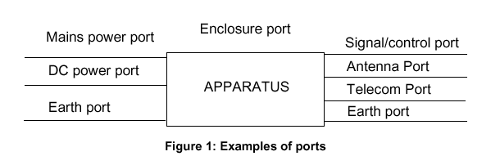
Spurious emission from ITU-R SM 329-7 [11] | Emission on a frequency, or frequencies, which are outside the necessary bandwidth and the level of which may be reduced without affecting the corresponding transmission of information. Spurious emissions include harmonic emissions, parasitic emissions, intermodulation products and frequency conversion products but exclude out-of-band emissions.  NOTE 1 – For the purpose of this Recommendation all emissions, including intermodulation products, conversion products and parasitic emissions, which fall at frequencies separated from the centre frequency of the emission by 250% or more of the necessary bandwidth of the emission will generally be considered spurious emissions.
Telecommunication port | ports which are intended to be connected to telecommunication networks (e.g. public switched telecommunication networks, integrated services digital networks), local area networks (e.g. Ethernet, Token Ring) and similar networks (see CISPR 22 [14]).
Transient phenomena | Pertaining to or designating a phenomena or a quantity which varies between two consecutive steady states during a time interval short compared with the time-scale of interest (IEC 60050-161 [9])
Traffic mode | is the state of User Equipment (UE) when switched on and with Radio Resource Control (RRC) connection established.
Universal mobile telecommunications system (UMTS) | The telecommunications system, incorporating mobile cellular and other functionality, that is the subject of specifications produced by 3GPP
User equipment (UE) | is a "Mobile Station" (MS) which is an entity capable of accessing a set of UMTS services via one or more radio interfaces. This entity may be stationary or in motion within the UMTS service area while accessing the UMTS services, and may simultaneously serve one or more users.

3.2 Abbreviations
For the purposes of the present document, the following abbreviations apply:
AC Alternating Current
BCCH Broadcast Control Channel *)
BS Base Station
BSS Base Station System
BTS Base Transceiver Station
CCCH Common Control Channel *)
CW Continuous Wave (unmodulated carrier wave)
DC Direct Current
DL Down Link (From BTS to UE)
DTX Discontinuous Transmission *)
EMC Electromagnetic Compatibility
ESD ElectroStatic Discharge
EUT Equipment Under Test (UE or UE with ancillaries)
FDD Frequency Division Duplex
LISN Line Impedance Stabilizing Network
MRP Mouth Reference Point (artificial head)
PCCPCH Primary Common Control Physical Channel
RF Radio Frequency
rms root mean square
RRC Radio Resource Control
SPL Sound Pressure Level
TCH Traffic channel
TDD Time Division Duplex
UARFCN UTRA Absolute Radio Frequency Channel Number *)
UE User Equipment
UL Up Link (From UE to BTS)
UMTS Universal Mobile Telecommunication System
UTRA Universal Terrestrial Radio Access network
*) refer to Terminology specifications 3G TS 21.905 and 3G TS 25.990 [8] for further details.

4 Test conditions

4.1 General
The equipment shall be tested under normal test conditions according to the relevant product and basic standards (See Annex D of TS 25.101 for environmental conditions). If these conditions are not specified then the manufacturers declared range of humidity, temperature and supply voltage shall be used. The test conditions shall be recorded in the test report.
Whenever the Equipment under test (EUT) is provided with a detachable antenna, the EUT shall be tested with the antenna fitted in a manner typical of normal intended use, unless specified otherwise.
Where the equipment incorporates an external 50 Ω RF antenna connector that is normally connected via a coaxial cable, then the wanted signal to establish a communication link also uses a coaxial cable;
Where the equipment has an external 50 Ω RF antenna connector that is not normally connected via a coaxial cable or where the equipment has no external 50 Ω RF connector (i.e., integral antenna equipment), then the wanted signal, to establish a communication link, shall be delivered from the equipment to an antenna located within the test environment;

4.2 Arrangements for establishing a communication link
The wanted RF input signal nominal frequency shall be selected by setting the UTRA Absolute Radio Frequency Channel Number (UARFCN) to an appropriate number.
A communication link shall be set up with a suitable base station simulator (hereafter called "the test system"). The test system shall be located outside of the test environment
When the EUT is required to be in the traffic mode, a call is set up according to the Generic call set-up procedure and the following conditions shall be met:
See TS 34.108 [10] and TS 34.109 [15] Logical Test Interface for details regarding generic call set-up procedure and BER, BLER test loop scenarios.
- set and send continuously Up power control commands to the UE;
- the DTX shall be disabled;
- Inner Loop Power Control shall be enabled;
- transmitting and/or receiving (UL/DL) bit rate for reference test channel shall be 12.2 kbps;
- adequate measures shall be taken to avoid the effect of the unwanted signal on the measuring equipment;
- For immunity testing , the wanted input signal level shall be set to 40 dB above the reference sensitivity level to provide a stable communication link. The reference sensitivity level is defined in 3G TS 25.101 [12].
- For emission testing, the wanted input signal level shall be no more than 15 dB above the reference sensitivity level, such that the performance of the measuring receiver is not limited by strong signal effects.
When the EUT is required to be in the idle mode, the following conditions shall be met:
- UE shall be camped on a cell
- UE shall perform Location Registration (LR) before the test, but not during the test;
- UE´s neighbour cell list shall be empty;
- Paging repetition period and DRX cycle shall be set to minimum (shortest possible time interval);
For immunity tests subclause 4.3, shall apply and the conditions shall be as follows:

4.3 Narrow band responses on receivers
Responses on receivers or duplex transceivers occurring during the test at discrete frequencies, which are narrow band responses (spurious responses), are identified by the following method:
- If during an immunity test the quantity being monitored goes outside the specified tolerances, it is necessary to establish whether the deviation is due to an unwanted effect on the receiver of the UE or on the test system (narrow band response) or to a wide band (EMC) phenomenon. Therefore, the test shall be repeated with the UARFCN increased or decreased by 25 (DL / UL).
- if the deviation does not disappear, the procedure is repeated with the UARFCN increased or decreased by 50 from the original value (DL / UL);
- if the deviation does not disappear with the increased and/or decreased UARFCN, the phenomenon is considered wide band and therefore an EMC problem and the equipment fails the test.
Narrow band responses are disregarded.
The procedure above does not apply to conducted immunity tests in the frequency range 150 kHz to 80 MHz.

5 Performance assessment

5.1 General
The manufacturer shall at the time of submission of the equipment for test, supply the following information to be recorded in the test report:
- the primary functions of the radio equipment to be tested during and after the EMC testing;
- if applicable, the method to be used to verify that a communications link is established and maintained;
- the intended functions of the radio equipment which shall be in accordance with the documentation accompanying the equipment;
- the user-control functions and stored data that are required for normal operation and the method to be used to assess whether these have been lost after EMC stress;
- the ancillary equipment to be combined with the radio equipment for testing (where applicable);
- information about ancillary equipment intended to be used with the radio equipment;
- an exhaustive list of ports, classified as either power or signal/control. Power ports shall further be classified as AC or DC power;
- the humidity range, temperature, and supply voltage for all equipment submitted for testing.

5.2 Equipment which can provide a continuous communication link
The test arrangement and signals, given in clause 4, apply to radio equipment or a combination of radio equipment and ancillary equipment that permits the establishment of a communication link. The assessment of equipment performance shall be based on speech call and data transfer according to the criteria in clause 6.

5.3 Equipment which can only provide a discontinuous communication link (packet data/transmission)
If the equipment does not permit or allow for a communications link to be established and maintained during the EMC tests (as in subclause 5.2), the manufacturer shall define the performance assessment. The manufacturer shall provide the method of observing the degradation of performance of the equipment.

5.4 Equipment which does not provide a communication link
If the equipment is of a specialised nature which does not permit a communication link to be established, the manufacturer shall define the method of test to determine the acceptable level of performance or degradation of performance during and/or after the test. The manufacturer shall provide the method of observing the degradation of performance of the equipment.
The performance assessment carried out shall be simple, but at the same time give adequate proof that the primary functions of the equipment are operational.

5.5 Conformance of ancillary equipment
Ancillary equipment shall be tested with it connected to a UE in which case compliance shall be demonstrated to the appropriate clauses of the present document.

5.6 Equipment classification
Equipment is classified according to the source of power.
- if power is derived from a fixed AC or DC supply network installation the equipment is classified "for fixed use";
- if power is derived from a vehicular power supply (car battery + alternator) the equipment is classified "for vehicular use";
- if power is derived from an integral battery the equipment is classified "for portable use";

6 Performance criteria
The maintenance of a communications link shall be assessed by using an indicator, which may be part of the test system or the equipment under test.
Specifically the equipment shall meet the minimum performance criteria as specified in the following subclauses as appropriate.
Portable equipment intended for use whilst powered by the main battery of a vehicle shall additionally fulfil the applicable requirements set out by the present document for mobile equipment for vehicular use.
Portable equipment intended for use whilst powered by AC mains shall additionally fulfil the applicable requirements set out by the present document for equipment for fixed use.
If an equipment is of such nature, that the performance criteria described in the following subclauses are not appropriate, then the manufacturer shall declare, for inclusion in the test report, his own specification for an acceptable level of performance or degradation of performance during and/or after testing, as required by the present document.
The performance criteria specified by the manufacturer shall give the same degree of immunity protection as called for in the following subclauses.
In addition, the test shall also be performed in idle mode to ensure the transmitter does not unintentionally operate.
The requirements apply to all types of UTRA (FDD or TDD) for the UE.

6.1 Performance criteria for continuous phenomena
A communication link shall be established at the start of the test, and maintained during the test, subclauses 4.1 and 4.2.
In the data transfer mode, the performance criteria can be one of the following error ratios:
- if the BER (as referred in TS34.109) is used, it shall not exceed 0.001 during the test sequence;
- if the BLER (as referred in TS34.109) is used, it shall not exceed 0.01 during the test sequence;
In the speech mode, the performance criteria shall be that the up link and downlink speech output levels shall be at least 35 dB less than the recorded reference levels, when measured through an audio band pass filter of width 200 Hz, centred on 1 kHz (Annex A).
NOTE: When there is a high level noise background noise present the filter bandwidth can be reduced down to a minimum of 40 Hz.
At the conclusion of the test, the EUT shall operate as intended with no loss of user control functions or stored data, and the communication link shall have been maintained.
In addition to confirming the above performance in traffic mode, the test shall be performed in idle mode, and the transmitter shall not unintentionally operate.

6.2 Performance criteria for Transient phenomena
A communications link shall be established at the start of the test, subclauses 4.1 and 4.2.
At the conclusion of each exposure the EUT shall operate with no user noticeable loss of the communication link.
At the conclusion of the total test comprising the series of individual exposures, the EUT shall operate as intended with no loss of user control functions or stored data, as declared by the manufacturer, and the communication link shall have been maintained.
In addition to confirming the above performance in traffic mode, the test shall also be performed in idle mode, and the transmitter shall not unintentionally operate.

7 Applicability overview tables

7.1 Emission

Table 1: Emission applicability
 |  | Equipment test requirement
Phenomenon | Application | Equipment connected to fixed AC or DC power installations | Equipment connected to vehicular DC supplies | Equipment powered by integral battery | Reference subclause in the present document | Reference Standard
Radiated emission | Enclosure | applicable | applicable | applicable | 8.2 | ITU-R SM.329-7 1997 [11]  TS25.101 [12]
Conducted emission | DC power input/output port | applicable | applicable | not applicable | 8.3 | CISPR 22 [14],  CISPR 16-1 [16]
Conducted emission | AC mains input/output port | applicable | not applicable | not applicable | 8.4 | CISPR 22 [14],
Harmonic current emissions | AC mains input port | applicable | not applicable | not applicable | 8.5 | IEC 61000-3-2 [17]
Voltage fluctuations and flicker | AC mains input port | applicable | not applicable | not applicable | 8.6 | IEC 61000-3-3 [18]

7.2 Immunity

Table 2: Immunity applicability
 |  | Equipment test requirement
Phenomenon | Application | Equipment connected to fixed AC or DC power installations | Equipment connected to vehicular DC supplies | Equipment powered by integral battery | Reference subclause in the present document | Reference standard
RF electromagnetic field (80 MHz to 1000 MHz) | Enclosure | applicable | applicable | applicable | 9.2 | IEC 61000-4-3 [20]
Electrostatic discharge | Enclosure | applicable | applicable | applicable | 9.3 | IEC 61000-4-2 [19]
Fast transients common mode | Signal and control ports, DC and AC power input ports | applicable | not applicable | not applicable | 9.4 | IEC 61000-4-4 [21]
RF common mode  0,15 MHz to 80 MHz | Signal and control ports, DC and AC power input ports | applicable | applicable | applicable | 9.5 | IEC 61000-4-6 [23]
Transients and surges, vehicular environment | DC power input ports | not applicable | applicable | not applicable | 9.6 | ISO 7637 Part 1 [6]  And  ISO 7637 Part 2 [7]
Voltage dips and interruptions | AC mains power input ports | applicable | not applicable | not applicable | 9.7 | IEC 61000-4-11 [24]
Surges, common and differential mode | DC and AC power input ports | applicable | not applicable | not applicable | 9.8 | IEC 61000-4-5 [22]

8 Methods of measurement and limits for EMC emissions

8.1 Test configurations
This subclause defines the configurations for emission tests as follows:
- the equipment shall be tested under normal test conditions;
- the test configuration shall be as close to normal intended use as possible;
- if the equipment is part of a system, or can be connected to ancillary equipment, then it shall be acceptable to test the equipment while connected to the minimum configuration of ancillary equipment necessary to exercise the ports;
- if the equipment has a large number of ports, then a sufficient number shall be selected to simulate actual operation conditions and to ensure that all the different types of termination are tested;
- the test conditions, test configuration and mode of operation shall be recorded in the test report;
- ports which in normal operation are connected shall be connected to an ancillary equipment or to a representative piece of cable correctly terminated to simulate the input/output characteristics of the ancillary equipment, Radio Frequency (RF) input/output ports shall be correctly terminated;
- ports that are not connected to cables during normal operation, e.g. service connectors, programming connectors; temporary connectors etc. shall not be connected to any cables for the purpose of EMC testing. Where cables have to be connected to these ports, or interconnecting cables have to be extended in length in order to exercise the EUT, precautions shall be taken to ensure that the evaluation of the EUT is not affected by the addition or extension of these cables;
- emission tests shall be performed in two modes of operation: - with a communication link established (traffic mode); and
- in the idle mode.

8.2 Radiated Emission
This test is applicable to radio communications equipment and ancillary equipment.
This test shall be performed on the radio equipment and/or a representative configuration of the ancillary equipment.

8.2.1 Definition
This test assesses the ability of radio equipment and ancillary equipment to limit unwanted emissions from the enclosure port.

8.2.2 Test method
The site shall be a fully anechoic chamber (FAC) simulating the free-space conditions. EUT shall be placed on a non-conducting support. Maximum average power of any spurious components shall be detected by the test antenna and measuring receiver (e.g. a spectrum analyzer).
At each frequency at which a component is detected, the EUT shall be rotated to obtain maximum response, and the effective radiated power (e.r.p.) of that component determined by a substitution measurement, which shall be the reference method. The measurement shall be repeated with the test antenna in the orthogonal polarization plane.
NOTE: Effective radiated power e.r.p. refers to the radiation of a half wave tuned dipole instead of an isotropic antenna. There is a constant difference of 2.15 dB between e.i.r.p. and e.r.p.
e.r.p. (dBm) = e.i.r.p. (dBm) − 2.15 Ref. ITU-R SM. 329-7 ANNEX 1 [11]
Measurements are made with a tuned dipole antenna or a reference antenna with a known gain referenced to an isotropic antenna.
If a different test site or method is used, this shall be stated in the test report. The results shall be converted to the reference method values and the validity of the conversion shall be demonstrated.

8.2.3 Limits
The references for these requirements are ITU-R SM 329-7 [11] and TS 25.101 subclauses 6.6.3.1. and 7.9.1. [12]
The frequency boundary and reference bandwidths for the detailed transitions of the limits between the requirements for out of band emissions and spurious emissions are based on ITU-R SM 329-7 [11].
These requirements are only applicable for frequencies, which are greater than 12.5 MHz away from the UE centre carrier frequency
Table 3.1: Radiated Spurious emissions requirements
Frequency | Minimum requirement (e.r.p.)/ Reference Bandwidth  Idle mode | Minimum requirement (e.r.p.) / Reference Bandwidth  Traffic mode
30 MHz ≤ f < 1000 MHz | -57dBm / 100 kHz | -36 dBm / 100 kHz
1 GHz ≤ f < 12.75 GHz  fc – 12.5 MHz < f < fc + 12.5 MHz | -47dBm / 100 kHz  Not defined | -30 dBm / 1 MHz  Not defined

NOTE: fc is the centre frequency of the TCH. The frequency range fc ± 12.5 MHz are covered by the "Out of Band" emission requirements of 3G TS 34.121[2] and 3G TS 34.122 [3].

8.3 Conducted emission DC power input/output port
This test is applicable to all equipment, which may have DC cables longer than 3 m.
If the DC power cable of the UE and/or the ancillary equipment is intended to be less than 3 m in length, and intended only for direct connection to a dedicated AC to DC power supply, then the measurement shall be performed only on the AC power input of that power supply as specified in subclause 8.4.
This test shall be performed on a representative configuration of the radio equipment or a representative configuration of the combination of radio and ancillary equipment.

8.3.1 Definition
This test assesses the ability of radio equipment and ancillary equipment to limit internal noise from the DC power input/output ports.

8.3.2 Test method
The test method shall be in accordance with CISPR 22 [14], and the Line Impedance Stabilising Networks (LISN) shall be connected to a DC power source.
In the case of DC output ports, the ports shall be connected via a LISN to a load drawing the rated current of the source.
A measuring receiver shall be connected to each LISN measurement port in turn and the conducted emission recorded. The LISN measurement ports not being used for measurement shall be terminated with a 50 Ω load.
The equipment shall be installed with a ground plane as defined in CISPR 22 [14], The reference earth point of the LISNs shall be connected to the reference ground plane with a conductor as short as possible.
The measurement receiver shall be in accordance with the requirements of section one of CISPR 16-1 [16]

8.3.3 Limits
The equipment shall meet the limits defined in table 4 (including the average limit and the quasi-peak limit) when using, respectively, an average detector receiver and a quasi-peak detector receiver and measured in accordance with the method described in subclause 8.2.2 above. If the average limit is met when using a quasi-peak detector, the equipment shall be deemed to meet both limits and measurement with the average detector receiver is not necessary.

Table 4: Limits
Frequency range | Quasi-peak | Average
> 0,15-0,5 MHz | 66 - 56 dBµV | 56 - 46 dBµV
> 0,5- 5 MHz | 56 dBµV | 46 dBµV
> 5-30 MHz | 60 dBµV | 50 dBµV
NOTE: The limit decreases linearly with the logarithm of the frequency in the range 0,15 MHz to 0,50 MHz.

8.4 Conducted emissions, AC mains power input/output port
This test is applicable to equipment powered by the AC mains.
This test is not applicable to AC output ports, which are connected directly (or via a switch or circuit breaker) to the AC input port.
This test shall be performed on a representative configuration of the radio equipment or a representative configuration of the combination of radio and ancillary equipment.

8.4.1 Definition
This test assesses the ability of radio equipment and ancillary equipment to limit internal noise from the AC mains power input/output ports.

8.4.2 Test method
The test method shall be in accordance with CISPR 22 [14],
Mains connected ancillary equipment which is not part of the EUT shall be connected to the mains via a separate LISN. According to subclause 11.9 of CISPR 16-1 [16], the Protective Earth (PE) wire shall also be terminated by a 50 Ω//50 μH common mode RF impedance.

8.4.3 Limits
The equipment shall meet the limits defined in table 5 (including the average limit and the quasi-peak limit) when using, respectively, an average detector receiver and a quasi-peak detector receiver and measured in accordance with the method described in subclause 8.3.2 above. If the average limit is met when using a quasi-peak detector, the equipment shall be deemed to meet both limits and measurement with the average detector receiver is not necessary.

Table 5: Limits for conducted emissions
Frequency range | Quasi-peak | Average
> 0,15-0,5 MHz | 66 - 56 dBµV | 56 - 46 dBµV
> 0.5- 5 MHz | 56 dBµV | 46 dBµV
> 5-30 MHz | 60 dBµV | 50 dBµV
NOTE: The limit decreases linearly with the logarithm of the frequency in the range 0,15 MHz to 0,50 MHz.

8.5 Harmonic current emissions (AC mains input port)
The requirements of IEC 61000-3-2 [17] for harmonic current emission apply for equipment covered by the scope of the present document.

8.6 Voltage fluctuations and flicker (AC mains input port)
The requirements of IEC 61000-3-3 [18] for voltage fluctuations and flicker apply for equipment covered by the scope of the present document.

9 Test methods and levels for immunity tests

9.1 Test configurations
This subclause defines the configurations for immunity tests as follows:
- the equipment shall be tested under normal test conditions as specified in the core specification ,e.g., TS 34.109 [15];
- the test configuration shall be as close to normal intended use as possible;
- if the equipment is part of a system, or can be connected to ancillary equipment, then it shall be acceptable to test the equipment while connected to the minimum configuration of ancillary equipment necessary to exercise the ports;
- if the equipment has a large number of ports, then a sufficient number shall be selected to simulate actual operation conditions and to ensure that all the different types of termination are tested;
- the test conditions, test configuration and mode of operation shall be recorded in the test report;
- ports which in normal operation are connected shall be connected to an ancillary equipment or to a representative piece of cable correctly terminated to simulate the input/output characteristics of the ancillary equipment, Radio Frequency (RF) input/output ports shall be correctly terminated;
- ports, which are not, connected to cables during normal operation, e.g. service connectors, programming connectors, temporary connectors etc. shall not be connected to any cables for the purpose of EMC testing. Where cables have to be connected to these ports, or interconnecting cables have to be extended in length in order to exercise the EUT, precautions shall be taken to ensure that the evaluation of the EUT is not affected by the addition or extension of these cables;
- the test arrangements for transmitter and receiver sections of the transceiver are described separately for the sake of clarity. However, where possible the test of the transmitter section and receiver section of the EUT may be carried out simultaneously to reduce test time;
- immunity tests shall be performed in two modes of operation:
- with a communication link established (traffic mode); and
- in the idle mode.
See subclauses 6.1 and 6.2.

9.2 RF electromagnetic field (80 MHz - 1000 MHz)
The test shall be performed on a representative configuration of the equipment or a representative configuration of the combination of UE and ancillary equipment.

9.2.1 Definition
This test assesses the ability of UE and ancillary equipment to operate as intended in the presence of a radio frequency electromagnetic field disturbance at the enclosure.

9.2.2 Test method and level
The test method shall be in accordance with IEC 61000-4-3 [20]
- for UE and ancillary equipment the following requirements shall apply;
- the test level shall be 3 V/m amplitude modulated to a depth of 80 % by a sinusoidal audio signal of 1 kHz;
- the stepped frequency increments shall be 1 % of the momentary frequency;
- when using the max hold detector method (see ANNEX A) at each test frequency step initially an unmodulated test signal shall be applied. Then the test modulation shall be applied;
- the test shall be performed over the frequency range 80 MHz to 1 000 MHz;
- responses in stand alone receivers or receivers which are part of transceivers occurring at discrete frequencies which are narrow band responses, shall be disregarded, see subclause 4.3;
- the frequencies selected during the test shall be recorded in the test report.

9.2.3 Performance criteria
The performance criteria of subclause 6.1 shall apply.

9.3 Electrostatic discharge
The test shall be performed on a representative configuration of the equipment or a representative configuration of the combination of UE and ancillary equipment.

9.3.1 Definition
This test assesses the ability of UE and ancillary equipment to operate as intended in the event of an electrostatic discharge.

9.3.2 Test method and level
The test method shall be in accordance with IEC 61000-4-2 [19]:
- for contact discharge, the equipment shall pass at ±2 kV and ±4 kV;
- for air discharge the equipment shall pass at ±2 kV, ±4 kV and ±8 kV (only for non-conducting surfaces, see IEC 61000-4-2 [19]).
NOTE: The EUT shall be fully discharged between each ESD exposure by connecting its ground point (where applicable) the HCP by a resistive wire with a 470 kΩ. resistor in either end.

9.3.3 Performance criteria
The performance criteria of subclause 6.2 shall apply.

9.4 Fast transients common mode
The test shall be performed on AC mains power input ports.
This test shall be performed on signal ports, control ports and DC power input/output ports if the cables may be longer than 3 m.
Where this test is not carried out on a port or any other ports because the manufacturer declares that it is not intended to be used with cables longer than 3 m, a list of ports which were not tested for this reason shall be included in the test report.
This test shall be performed on a representative configuration of the equipment or a representative configuration of the combination of UE and ancillary equipment.

9.4.1 Definition
This test assesses the ability of UE and ancillary equipment to operate as intended in the event of fast transients present on one of the input/output ports.

9.4.2 Test method and level
The test method shall be in accordance with IEC 61000-4-4 [21]
- the test level for signal and control ports shall be 0,5 kV open circuit voltage as given in IEC 61000-4-4 [21];
- the test level for DC power input/output ports shall be 0,5 kV open circuit voltage as given in IEC 61000-4-4 [21];
- the test level for AC mains power input ports shall be 1 kV open circuit voltage as given in IEC 61000-4-4 [21].

9.4.3 Performance criteria
The performance criteria of subclause 6.2 shall apply.

9.5 RF common mode (0,15 MHz to 80 MHz)
This test is applicable for UE for fixed, mobile, and portable use and for ancillary equipment.
This test shall be performed on signal, control and DC power input/output ports, which may have cables longer than 3 m.
This test shall be performed on AC mains power input/output ports of UE for fixed use and for fixed ancillary equipment. Where this test is not carried out on a port or any other ports because the manufacturer declares that it is not intended to be used with cables longer than stated above, a list of ports which were not tested shall be included in the test report.
This test shall be performed on a representative configuration of the UE or a representative configuration of the combination of UE and ancillary equipment.

9.5.1 Definition
This test assesses the ability of equipment and ancillary equipment to operate as intended in the presence of a radio frequency electromagnetic disturbance.

9.5.2 Test method and level
The test method shall be in accordance with IEC 61000-4-6 [23].
- the test signal shall be amplitude modulated to a depth of 80 % by a sinusoidal audio signal of 1 kHz;
- the stepped frequency increments shall be either 50 kHz or 1 % frequency increment of the momentary frequency in the frequency range 150 kHz - 5 MHz and 1 % frequency increment of the momentary frequency in the frequency range 5 MHz - 80 MHz;
- when using the max hold detector method (see ANNEX A) at each test frequency step initially an unmodulated test signal shall be applied. Then the test modulation shall be applied;
- the test level shall be severity level 2 as given in IEC 61000-4-6 [23] corresponding to 3 V rms, at a transfer impedance of 150 Ω;
- the test shall be performed over the frequency range 150 kHz - 80 MHz;
- responses of stand alone receivers or receivers which are part of transceivers occurring at discrete frequencies which are narrow band responses, shall be disregarded, see subclause 4.3;
- the frequencies selected during the test and the test method used shall be recorded in the test report.

9.5.3 Performance criteria
The performance criteria of subclause 6.1 shall apply.

9.6 Transients and surges, vehicular environment
The tests are applicable to UE intended for use in a vehicular environment.
These tests shall be performed on 12 V and 24 V DC power input.
These tests shall be performed on a representative configuration of the equipment or a representative configuration of the combination of UE and ancillary equipment.

9.6.1 Definition
These tests assess the ability of UE and ancillary equipment to operate as intended in the event of transients and surges present on the DC power input ports in a vehicular environment.

9.6.2 Test method and level
The test method shall be in accordance with ISO 7637-1 [6] for nominal 12 V DC powered equipment and ISO 7637-2 [7] for nominal 24 V DC powered equipment. The requirements are detailed as follows:

9.6.2.1 12 V DC powered equipment
Where the manufacturer in his installation documentation requires the EUT to have a direct connection to the 12 V main vehicle battery the following requirements in accordance with ISO 7637-1 [6] shall apply:
- pulse 3a and 3b, level II (±50 V), with the test time reduced to 5 minutes for each;
Supply voltage V_{A} = 13,5 ± 0,5 V DC
- pulse 4, level II, 5 pulses, with the characteristics as follows:
Vs = -5 V, Va = -2,5 V, t6 = 25 ms, t8 = 5 s, tf = 5 ms.
Supply voltage V_{B} = 12,0 ± 0,2 V DC
Where the manufacturer does not require the EUT to have a direct connection to the 12 V main vehicle battery, the following pulses apply in addition:
- pulse 1, level II (-50 V), t₁ = 2,5 s, 10 pulses; Supply voltage V_{A} = 13,5 ± 0,5 V DC;
- pulse 2, level II (+50 V), t₁ = 2,5 s, 10 pulses. Supply voltage V_{A} = 13,5 ± 0,5 V DC.
Where the manufacturer declares that the EUT requires a direct connection to the vehicle battery, and the corresponding tests are not carried out, this shall be stated in the test report.

9.6.2.2 24 V DC powered equipment
Where the manufacturer in his installation documentation requires the EUT to have a direct connection to the 24 V main vehicle battery the following requirements in accordance with ISO 7637-2 [7] shall apply:
- pulse 3a and 3b, level II (±70 V), with the test time reduced to 5 minutes for each;
Supply voltage V_{A} = 27 ± 1 V DC
- pulse 4, level II, 5 pulses, with the characteristics as follows:
Vs = -10 V, Va = -5 V, t6 = 25 ms, t8 = 5 s, tf = 5 ms.
Supply voltage V_{B} = 24 ± 0,4 V DC
Where the manufacturer does not require the EUT to have a direct connection to the 24 V main vehicle battery, the following pulses apply in addition:
- pulse 1, level II (-100 V), t₁ = 2,5 s, 10 pulses; Supply voltage V_{A} = 27 ± 1 V DC;
- pulse 1b, level II (-550 V), t1 = 2,5 s, 10 pulses Ri = 100 Ω;
Supply voltage V_{A} = 27 ± 1 V DC;
- pulse 2, level II (+50 V), t₁ = 2,5 s, 10 pulses. Supply voltage V_{A} = 27 ± 1 V DC.
Where the manufacturer declares that the EUT requires a direct connection to the vehicle battery, and the corresponding tests are not carried out, this shall be stated in the test report.
For UE and ancillary equipment designed to operate at both DC voltages and where no manual adjustments are required, the requirement 9.6.2.2 and pulse 4 from 9.6.2.1 shall apply.
For UE designed to operate at 12 V DC power supply, but operating from a 24 V DC power adapter ancillary, then the UE shall comply with the requirements in 9.6.2.1 and the configuration of the UE and the power adapter shall comply with the requirements of 9.6.2.2.

9.6.3 Performance criteria
The performance criteria of subclause 6.2 shall apply. However, where the equipment is powered without the use of a parallel battery back-up, for pulses 1, 1a, 1b, 2 and 4 the communications link need not be maintained and may have to be re-established and volatile user data may have been lost.

9.7 Voltage dips and interruptions
The tests shall be performed on AC mains power input ports.
These tests shall be performed on a representative configuration of the UE or a representative configuration of the combination of UE and ancillary equipment.

9.7.1 Definition
These tests assess the ability of UE and ancillary equipment to operate as intended in the event of voltage dips and interruptions present on the AC mains power input ports.

9.7.2 Test method and level
The following requirements shall apply.
The test method shall be in accordance with IEC 61000-4-11 [24].
The test levels shall be:
- a voltage dip corresponding to a reduction of the supply voltage of 60 % for 5 periods;
- a voltage interruption corresponding to a reduction of the supply voltage of > 95 % for 250 periods.

9.7.3 Performance criteria
The performance criteria of subclause 6.2 shall apply. However, in the case where the equipment is powered solely from the AC mains supply (without the use of a parallel battery back-up the communications link need not be maintained and may have to be re-established and volatile user data may have been lost. In the event of loss of the communications link or in the event of loss of user data, this fact shall be recorded in the test report, the product description and the user documentation.

9.8 Surges, common and differential mode
The tests shall be performed on AC mains power input ports.
These tests shall be performed on a representative configuration of the UE or a representative configuration of the combination of UE and ancillary equipment.

9.8.1 Definition
These tests assess the ability of UE and ancillary equipment to operate as intended in the event of surges being present at the AC mains power input ports.

9.8.2 Test method and level
The test method shall be in accordance with IEC 61000-4-5 [22].
The following requirements and evaluation of test results shall apply:
- the test level for ac mains power input ports shall be 1 kV line to ground and 0,5 kV line to line with the output impedance of the surge generator as given in the IEC 61000-4-5 [22];
- the test generator shall provide the 1,2/50 µsec pulse as defined in IEC 61000-4-5 [22].

9.8.3 Performance criteria
The performance criteria of sub-clause 6.2 shall apply.

Annex A (normative):
Performance assessment voice call. Audio break through

A.1 Calibration of audio levels
For the portable the audio calibration is performed as follows:
Set the EUT volume to provide the nominal audio level if specified by the manufacturer. If no such level is specified, the centre volume step shall be used.
Prior to the test sequence, the reference level of the speech output signal on both the downlink and uplink shall be recorded on the test instrumentation, as shown in figure A.1. The reference level shall be equivalent to the SPL of 0 dBPa at 1 kHz at the input of the acoustical coupler described in ETR 027 [25], for the downlink, and –5dBPs at 1 kHz at the mouth reference point (MRP) defined in ITU_T recommendation P.64 [26] for the uplink.
NOTE 1: The MRP is defined with respect to an artificial head defined in ITU-T P 76 [27] The handset shall be mounted on the artificial head such that the ear piece is centred at the artificial ear.
NOTE 2: If the equipment does not include acoustical transducers (e.g. a microphone or loudspeaker) the manufacturer shall specify the equivalent electrical reference levels.
The voice processor may often apply noise and echo cancellation algorithms, which attempt to eliminate or reduce steady state audio signals as e.g., the 1 kHz calibration signals. These algorithms may be disabled during the calibration procedure. Specialised test software may be required. If the algorithms can not be disabled then the reference level shall be measured using a max-hold detection on the audio level meter in order to determine the level before the noise and echo cancellation algorithms become effective.
In handsfree applications an external loudspeaker is used. The SPL from the external loudspeaker is normally much higher than from the earpiece of the portable in order overcome a high ambient noise level. The downlink reference level shall be increased in order to compensate for the difference. Alternatively, the distance between the loudspeaker and the measuring microphone shall be adjusted during the measurement procedure in accordance with the manufacturers specification. It is important that the dynamic range of the test instrumentation is not exceeded.
Normally no corrections are made to the uplink reference level. In case it is not possible to perform the above calibration (e.g., a PC card with headset) the manufacturer shall specify the distance between the MRP and the microphone.
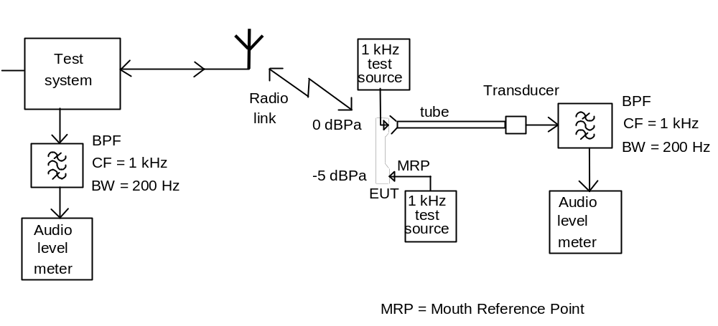
NOTE: The EUT is in position during calibration of the uplink, but not during calibration of the downlink where the EUT is replaced by the 1 kHz test audio source. During calibration of the uplink the mouthpiece shall be placed with respect to the MRP in a way representing intended use.
Figure A.1: Audio breakthrough measurement, calibration set-up for portable equipment

A.2 Measurement of audio levels
When the audio levels are measured during testing the EUT software shall be configured for voice applications. If the algorithms for noise and echo cancellation are not disabled, then the level shall be measured using a max-hold detection on the audio level meter in order to determine the level before the noise and echo cancellation algorithms become effective.
The level of the output signal from the downlink speech channel of the EUT at the mobile or portable's ear piece shall be assessed by measuring the Sound Pressure Level (SPL) as shown in figure A.2. When an external loudspeaker is used the acoustical coupler shall be fixed to the loudspeaker in the position used during the calibration. The level of the decoded output signal from the uplink speech channel of the EUT at the analogue output of the test system shall be measured. Pick up of extraneous background noise by the microphone of the EUT shall be minimised.
NOTE: If the equipment is designed for use with external transducers, they shall be included in the test configuration. If the equipment does not include acoustical transducers the line voltage developed across specified termination impedance may be measured
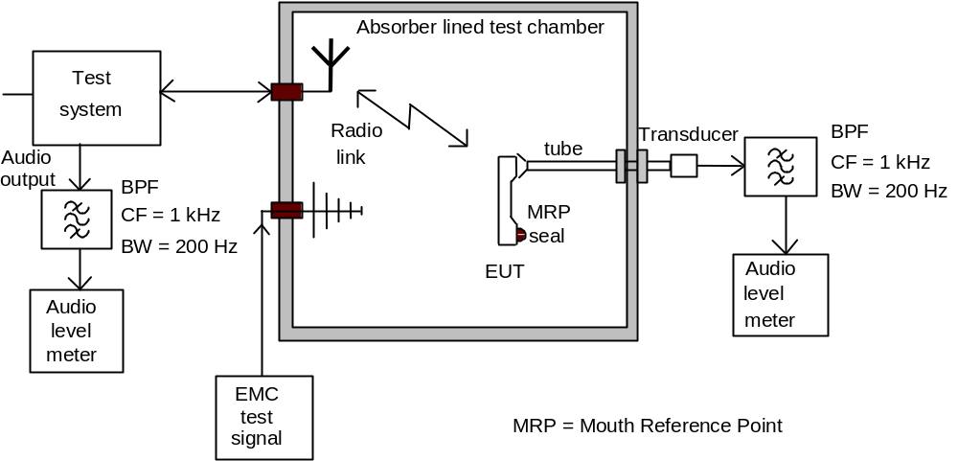

Figure A.2: Audio breakthrough measurement, test set-up for portable equipment

Annex B (normative):
Performance assessment of data transfer call. Error Ratios

B.1 Calibration of data transfer
For the EUT, calibration of the data transfer may be performed by assessing the Bit Error Ratio (BER), Block Error Ratio (BLER) or End- User data error ratio before applying the RF immunity test signal (defined in clauses 9.2 and 9.5).

B.2 Derivation of Error Ratios
The manufacturer shall provide the method for calculating the Error Ratio. Known data patterns shall be transferred bi-directionally from end-to-end (the whole of the UL and DL will be exercised). Performance assessment shall be made at each frequency step. Comparison between transmitted known data and received data shall result in the Error Ratio.
The data patterns used should be of sufficient length to give valid results and should be equivalent to the used channel bit rate.
Possible data patterns for assessing the Error Ratio are BER, BLER and User Data. Detailed description of BER and BLER can be found from 3G TS 34.109 [15]
End- User Data may be used where BER and BLER measurements are not appropriate, and is a manufacturers decision (see below):
Note: For example, in the cases when the EUT consists of UE with data application ancillary and the data application ancillary itself does not support a loopback function that can be applied for the assessement of BER or BLER, as specified in TS34.109[15]. This would lead into a situation where the data application ancillary is not exercised, i.e the data transfer loop is not end-to-end.
The characteristics of the End- User Data used for testing (format, size, typical data throughput rate, additional error corrections etc.) and the necessary test equipment shall be delivered to enable the assessment of the EUT.
Following formula may apply to End- User Data:

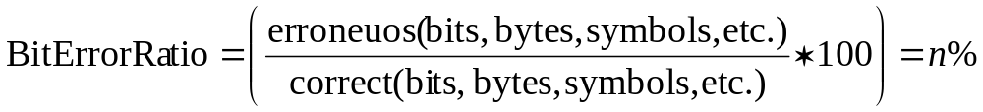

(In case that high Error Ratios exist, ensure that errors are a consequence of EMC stress).

B.3 EUT without data application ancillary
Data monitoring Devices are here considered as part of the Test System. Arrangements should be made by the manufacturer, if needed, to couple the Data monitoring Device by a method which does not affect the radiated electromagnetic field (e.g. ultra sonic or optical).
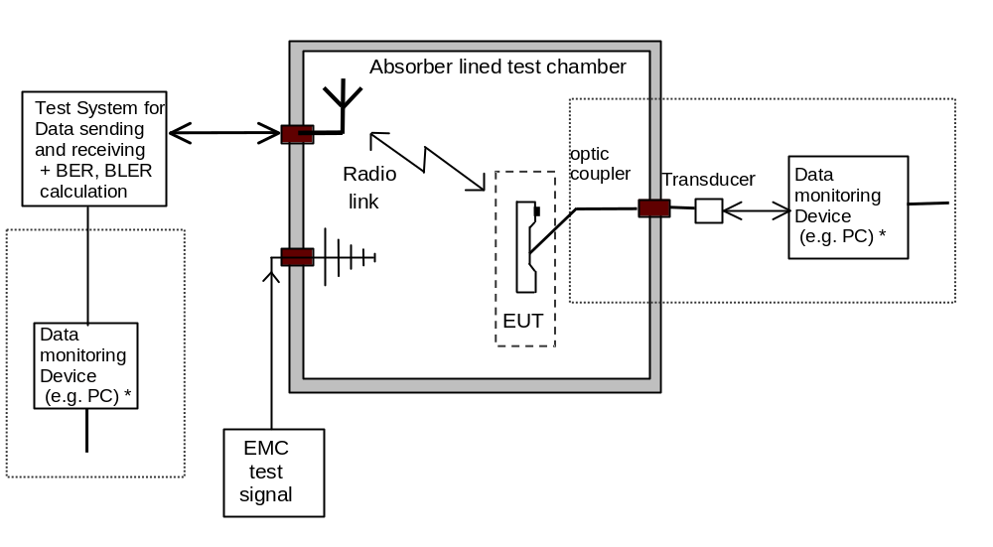
Figure B.1: Error Ratio assessment, test set-up for EUT without data application ancillary.

B.4 EUT with data application ancillary
The Data monitoring Device is here considered as a part of the Test System. The Data application ancillary should be part of the data transfer (UL and DL) loop and is included in the EUT configuration.
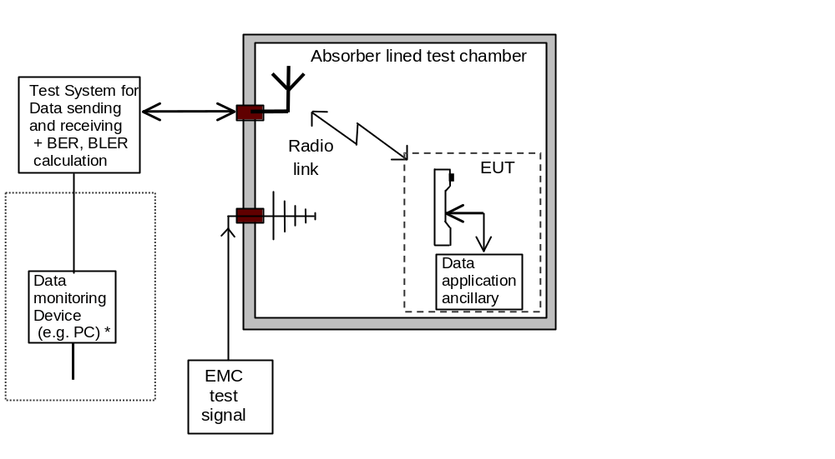
Figure B.2: Error ratio assessment, test set-up for EUT with data application ancillary.

History
Document history
Version 1.0.0 | July 1999 | TS xx.xxx 1st draft
Version 1.0.1 | August 1999 | TS xx.xxx 2nd draft
Version 1.1.0 | September 1999 | TS 34.124: equal to TS xx.xxx v1.0.1 with format changes
Version 1.2.0 | October 1999 | TS 34.124 3rd draft
Version 1.2.1 | November 1999 | Addition of Copyright Notification and Postal address. Format updating
Version 1.2.2 | December 1999 | Addition of some definitions to clause 3.0 and some editorial changes
Version 1.3.0 | February 2000 | Update references, abbreviations, and call set-up definitions
Version 2.0.0 | February 2000 | Discussed and amended by SWG T1 EMC at meeting #08, and unanimously agreed to be submitted to TSG T1 for release 99 in March 2000
Version 2.0.1 | March 2000 | Editorial correction in table 3.1. Presented to TSG T#7 for approval
Version 3.0.0 | March 2000 | Approved as v3.0.0 at TSG T#7

Meeting-1st-Level | Doc-1st-Level | CR | Rev | Subject | Cat | Version-Current | Version-New | Doc-2nd-Level
TP-09 | TP-000136 | 001 |  | Idle mode conditions and test loops | F | 3.0.0 | 3.1.0 | T1-000222
TP-09 | TP-000136 | 002 |  | Adding End- user data besides BER and BLER for EMC data testing | F | 3.0.0 | 3.1.0 | T1-000223
TP-09 | TP-000136 | 003 |  | Editorial modifications for purposes of clarification | D | 3.0.0 | 3.1.0 | T1-000224
TP-10 | TP-000222 | 004 |  | Editorial modifications for purposes of clarification. | D | 3.1.0 | 3.2.0 | T1-000320

